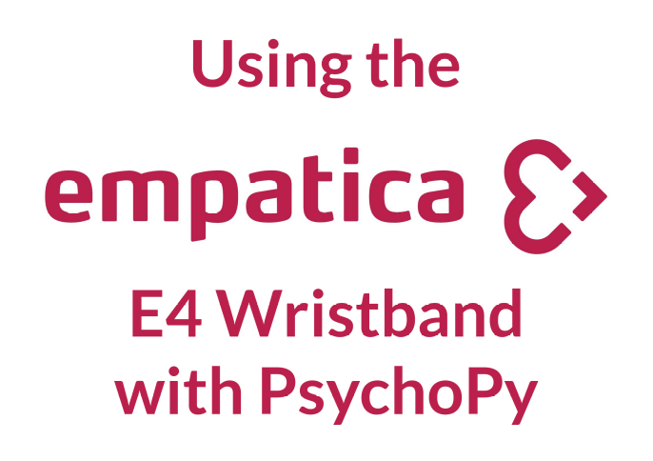
- Copy the file “Empatica.py” to the root experiment folder.
- Create a “Custom Code Component” at the beginning of your experiment.
- In the “Begin Experiment” tab of this component, copy the following:
import empatica as ep
sock = ep.connect()
ep.subscribe(sock, SENSORS)
- Replace SENSORS with the names of each sensor you wish to gather data for, each in quotation marks, separated by commas. For example:
val = el.getval(22002, 'gsr', 'acc')
- For each routine you would like to gather data in:
  - Create a “Custom Code Component” in that routine
  - In the “End Routine” tab of this component, copy the following:
val = ep.getval(sock)
  - Below that, copy the following:
thisExp.addData('epTime', t)
  - Then, for each sensor you are using, copy the following:
thisExp.addData('SENSOR', val['SENSOR'])
  - Replace SENSOR with the name of each sensor, for example:
thisExp.addData('gsr', val['gsr'])
thisExp.addData('acc', val['acc'])
  - Finally, add a line to tell Psychopy to move on to the next line in the data file:
thisExp.nextEntry()

